Final Project Report

Community Skills Exchange Platform



Project Supervisor
Amjad Iqbal Khan

Submitted By

F25PROJECTCC0AF (BC210408700)

Muhammadullah BC210408700

Software Projects & Research Section,
Department of Computer Sciences,
Virtual University of Pakistan


CERTIFICATE

This is to certify that Muhammadullah (BC210408700) have worked on and completed their Software Project at Software & Research Projects Section, Department of Computer Sciences, Virtual University of Pakistan in partial fulfillment of the requirement for the degree of BS in Computer Sciences under my guidance and supervision.

In our opinion, it is satisfactory and up to the mark and therefore fulfills the requirements of BS in Computer Sciences.

Supervisor / Internal Examiner

Amjad Iqbal Khan
Supervisor,
Software Projects & Research Section,
Department of Computer Sciences
Virtual University of Pakistan

___________________
(Signature)

External Examiner/Subject Specialist
<<External Supervisor Name>>

___________________
(Signature)

Accepted By:

_____________
(For office use)

EXORDIUM

In the name of Allah, the Compassionate, the Merciful.

Praise be to Allah, Lord of Creation,
The Compassionate, the Merciful,
King of Judgment-day!

You alone we worship, and to You alone we pray for help,
Guide us to the straight path

The path of those who You have favored,

Not of those who have incurred Your wrath,
Nor of those who have gone astray.

DEDICATION

I dedicate this project wholeheartedly to my beloved parents, whose endless love, unwavering support, and countless sacrifices have been the guiding light throughout my educational journey — their belief in me gave me the courage to dream and the strength to achieve. I also dedicate this work to my esteemed university, whose nurturing environment, dedicated faculty, and commitment to academic excellence provided me with the knowledge, skills, and opportunities to transform my ideas into reality. This achievement is as much theirs as it is mine.

ACKNOWLEDGEMENT

I would like to express my sincere gratitude to my project supervisor Mr. Amjad Iqbal Khan for his guidance, constant encouragement, and insightful feedback throughout the development of this project. His expertise and patience helped me overcome challenges and refine my work to meet the highest standards. I’m also thankful to all my teachers and faculty members of the Department of Computer Science at Virtual University of Pakistan for equipping me with the technical knowledge and problem-solving skills essential for this endeavor. I also acknowledge the open-source community and developers behind Next.js, React, Strapi, TailwindCSS, and all other tools that made this project possible. Finally, I thank everyone who directly or indirectly contributed to the successful completion of this project — your support meant the world to me.
PREFACE

This project final report presents the complete design, development, and implementation of SkillShare - Community Skills Exchange Platform, a web-based application that enables users to exchange skills and knowledge through a time and skills bartering system without any monetary transactions. The report documents the entire software development lifecycle, from initial requirements gathering and feasibility analysis to system design, database architecture, frontend and backend development, testing, and deployment. Built using modern web technologies including Next.js 15, React 19, TailwindCSS, Strapi v5, and SQLite, the platform provides features such as user authentication, skill listing and browsing, exchange booking with status tracking, rating and review system, email notifications, and an admin dashboard for user management. This document serves as a comprehensive reference for understanding the technical architecture, functional requirements, and implementation details of the SkillShare platform.
TABLE OF CONTENTS

CHAPTER NO. 1
gathering & Analyzing info 10

1.1 Introduction

1.2 purpose

1.3 scope

1.4 definitions, acronyms and abbreviations

1.5 Project requirements

1.5.1 Functional Requirements

1.5.2 Non-Functional Requirements

1.6 use cases and usage scenarios

1.6.1 Use Case Diagrams

1.6.2 Usage Scenarios

1.7 Development Methodology

1.7.1 Chosen Methodology

1.7.2 Reasons for Chosen Methodology
1.7.2 Work Plan (Gantt Chart)
1.7.2 Project Schedule (Submission Calendar)

CHAPTER NO. 2
designing the project 12

2.1 Introduction

2.2 purpose

2.3 scope

2.4 definitions, acronyms and abbreviations

2.5 Architectural Representation (Architecture Diagram)

2.6 Dynamic Model: Sequence Diagrams

2.7 Object Model/Logical Model: Class Diagram

2.8 Database Model (Database Diagram)

2.9 Graphical User Interfaces

Chapter no.3
DEvelopment 13
3.1 Development plan (Architecture Diagram)

CHAPTER 1
Gathering & Analyzing Info

  - Introduction

The SkillShare - Community Skills Exchange Platform is a web-based application designed to facilitate the exchange of skills and knowledge between individuals through a time and skills bartering system, eliminating the need for monetary transactions. In today's world, many talented individuals possess valuable skills but cannot afford to pay for services they need, while others have expertise to share but lack a structured platform to connect with learners. SkillShare bridges this gap by creating a community-driven marketplace where users can register, create profiles, list skills they can offer, request skills they want to learn, browse and search for available skills by category and location, send exchange requests, track booking statuses, rate and review completed exchanges, and receive email notifications throughout the process. The platform features role-based access control with separate interfaces for regular users and administrators, where admins can manage users, suspend or activate accounts, moderate content, and view platform statistics. Built using Next.js 15 and React 19 for the frontend, Strapi v5 as the backend CMS, SQLite for data storage, and JWT for secure authentication, SkillShare provides a responsive, user-friendly, and scalable solution that promotes free education, community building, and the idea that everyone has something valuable to teach and something meaningful to learn.

  - purpose

The purpose of this project is to design and develop a web-based Community Skills Exchange Platform (SkillShare) that enables individuals to exchange skills, knowledge, and services through a time and skills bartering system — eliminating the need for monetary transactions. The platform aims to bridge the gap between people who possess valuable skills and those who seek to learn them but cannot afford paid services. By providing features such as user registration and profile management, skill listing with advanced search and filtering, exchange booking with status tracking, rating and review system, email notifications, and an admin dashboard for user management, SkillShare creates a trusted, accessible, and community-driven environment where knowledge is shared freely. The ultimate goal is to democratize learning, foster community connections, and promote the idea that everyone has something to teach and everyone has something to learn.

  - scope
The Community Skills Exchange Platform enables users to offer skills they can teach and request skills they wish to learn. The system allows user account creation, profile management, skill listing, searching for skills, and sending skill exchange requests. The platform facilitates communication between users by allowing them to accept or reject skill exchange requests.
The system supports the following features:
- User registration and login
- User profile creation and editing
- Adding skills offered and skills needed
- Browsing, filtering and searching for skills by category, location and keywords
- Sending, receiving, and managing skill exchange requests
- Viewing user profiles
- Email notifications for requests confirmation, booking and reminders
- Rating and review system after each exchange
- Role-based access: user, admin, and editor
- Admin dashboard for managing users, skills, and reports of abuse
- Content management (FAQ, About, Policies)
Out of Scope:
- Payment system
- Real-time video or audio calling
- Chabot or AI-based skill recommendations
- Third-party integrations
- Real-Time Chat or Messaging System
- Multi-Language Support
- Gamification Features (Badges, Levels, Points)
- Advanced Reporting & Analytics Dashboard
- Offline Mode

  - definitions, acronyms and abbreviations

Definitions:

Term | Definition
Skill Exchange | A barter-based transaction where two users trade their expertise without monetary payment
Booking | A formal request made by a user to learn a specific skill from another user
Suspension | Temporary deactivation of a user account by an administrator
Rating | A numerical score (1-5 stars) given by a user to evaluate an exchange experience

Acronyms & Abbreviations:

Acronym | Full Form
DB | Database
API | Application Programming Interface
FK | Foreign Key
JSX | JavaScript XML
UI | User Interface
UX | User Experience

1.5 Project requirements

1.5.1 Functional Requirements
- FR-1: The system shall allow users to register using an email and password.
- FR-2: The system shall verify user credentials during login.
- FR-3: The system shall allow users to log out securely.
- FR-4: The system shall allow users to create and update their profile information.
- FR-5: The system shall allow users to add the skills they can offer.
- FR-6: The system shall allow users to add the skills they want to learn.
- FR-7: The system shall store each user’s skill list in the database.
- FR-8: The system will display a list of available skills from all users.
- FR-9: The system shall allow users to search for skills by skill name.
- FR-10: The system shall allow users to filter skills by category.
- FR-11: The system shall allow users to view other users’ profiles and skills.
- FR-12: The system shall allow users to send skill exchange requests.
- FR-13: The system shall notify users when a new exchange request is received.
- FR-14: The system shall allow users to accept or reject exchange requests.
- FR-15: The system shall allow users to view the status of all requests (pending, accepted, rejected).
- FR-16: The system shall send email notifications for new skill exchange requests.
- FR-17: The system shall send email notifications for accepted or rejected requests.
- FR-18: The system shall allow users to submit a rating after completing a skill exchange.
- FR-19: The system shall allow users to write a review or feedback for other users.
- FR-20: The system shall support role-based authentication (User, Admin, and Editor).
- FR-21: The system shall allow editors to manage static content (FAQ, About, Policies).
- FR-22: The system shall allow admin to approve or reject skill posts.
- FR-23: The system shall allow admin to view and handle reports of abuse.
- FR-24: The system shall allow admin to manage skill categories.
- FR-25: The system shall allow admin or editors to update static content such as FAQ, about, and Policies pages.

    - Non-Functional Requirements

- NFR-1: The system should load the skills listing page within 3 seconds.
- NFR-2: The system should handle at least 100 concurrent user requests.
- NFR-3: The system should have an intuitive and user-friendly interface.
- NFR-4: The system shall be mobile responsive on different screen sizes.
- NFR-5: Only authenticated users should access profile and skill features.
- NFR-6: The system should protect user data from unauthorized modification.
- NFR-7: The system should be available 99% of the time.
- NFR-8: The system should recover gracefully from unexpected crashes.
- NFR-9: The system should work on modern browsers (Chrome, Firefox, Edge).
- NFR-10: The system will be built using modular and reusable components (React Components).
- NFR-11: The codebase will follow standard naming and documentation conventions.
- NFR-12: The system will ensure no duplicate user profiles or skill entries are stored.
- NFR-13: The system will validate all user input before saving.

1.6 use cases and usage scenarios
1.6.1 Use Case Diagrams

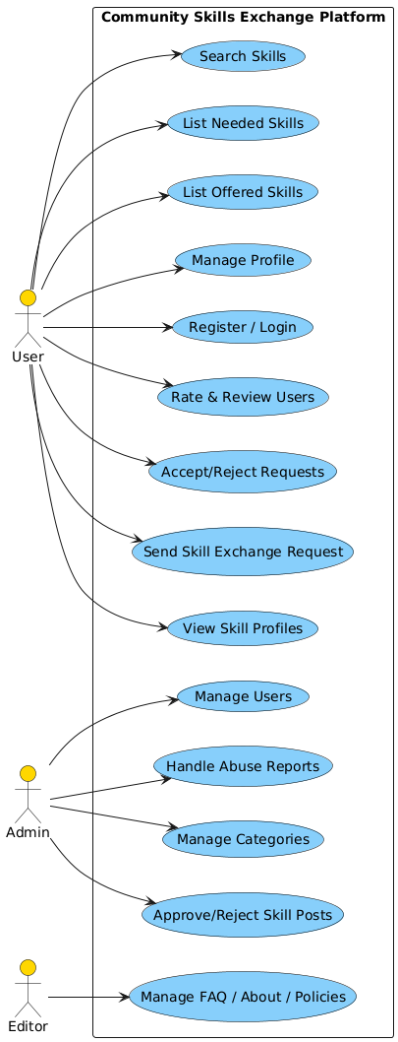

1.6.2 Usage Scenarios

Usage Scenario Table for User:

Use Case ID | Title | Description | Actors | Preconditions | Main Actions | Alternative Paths | Exceptions | Post conditions | Author
UC-1 | Register / Login | User creates an account or logs in using credentials | User | Valid email; System online | 1. Enter email/password  2. System verifies  3. System logs in | A1: Wrong password  A2: Invalid email  A3: Account exists | E1: DB Offline | User logged in | Ayan
UC-2 | Manage Profile | User updates profile details | User | User logged in | 1. Open profile  2. Edit fields  3. Save changes | A1: Invalid fields  A2: Cancel edit | E1: DB update fail | Profile updated | Ayan
UC-3 | Add Offered Skills | User adds skills they can teach | User | User logged in | 1. Open offered skills  2. Add skill  3. Save | A1: Empty fields  A2: Duplicate | E1: DB error | Skill added | Ayan
UC-4 | Add Needed Skills | User adds skills they want to learn | User | User logged in | 1. Open needed skills  2. Add skill  3. Save | A1: Empty fields  A2: Duplicate | E1: DB error | Skill saved | Ayan
UC-5 | Search Skills | User searches available skills | User | User logged in | 1. Enter keyword  2. System fetches  3. Display results | A1: No results | E1: Search index error | Results shown | Ayan
UC-6 | View Skill Profiles | User views another user's profile & skills | User | User logged in | 1. Open profile  2. View listed skills | A1: Profile hidden | E1: Profile fetch error | Profile displayed | Ayan
UC-7 | Send Skill Exchange Request | User sends a request for skill exchange | User | User logged in; Requested user exists | 1. Open profile  2. Click send request  3. Confirm | A1: User blocks requests | E1: Request creation error | Request sent | Ayan
UC-8 | Accept/Reject Request | User handles incoming requests | User | User logged in; Request exists | 1. Open requests  2. Accept/Reject | A1: Already responded | E1: Update fail | Request updated | Ayan
UC-9 | Book Session | User schedules session with another user | User | Request must be accepted | 1. Open accepted request  2. Choose time  3. Confirm | A1: Time slot unavailable | E1: Calendar error | Session booked | Ayan
UC-10 | Rate & Review User | User gives rating after session | User | Session completed | 1. Open review  2. Submit rating/comment | A1: Empty review | E1: DB error | Review added | Ayan

Usage Scenario Table for Admin:

Use Case ID | Title | Description | Actors | Preconditions | Main Actions | Alternative Paths | Exceptions | Post conditions | Author
UC-11 | Approve/Reject Skill Posts | Admin reviews newly added skills | Admin | Admin logged in | 1. View pending skills  2. Approve/Reject | A1: Already approved | E1: DB update fail | Skill moderated | Ayan
UC-12 | Manage Users | Admin manages user accounts | Admin | Admin logged in | 1. Open users  2. Ban/Unban  3. View reports | A1: User already banned | E1: Permission error | User updated | Ayan
UC-13 | Handle Abuse Reports | Admin processes user reports | Admin | Admin logged in; Report exists | 1. Open reports  2. Investigate  3. Take action | A1: False report | E1: Report fetch fail | Report resolved | Ayan
UC-14 | Manage Categories | Admin manages skill categories | Admin | Admin logged in | 1. Add/Update/Delete categories | A1: Duplicate name | E1: DB error | Categories updated | Ayan

Usage Scenario Table for Editor:

Use Case ID | Title | Description | Actors | Preconditions | Main Actions | Alternative Paths | Exceptions | Post conditions | Author
UC-15 | Manage FAQ/Policies/About | Editor updates website content | Editor | Editor logged in | 1. Open CMS  2. Update content  3. Save | A1: Invalid content | E1: CMS failure | Content updated | Ayan

1.7 Development Methodology

1.7.1 Chosen Methodology

1. Requirements Phase (Waterfall Component)
The project begins with detailed requirement gathering and documentation. All functional and nonfunctional requirements are identified clearly before development begins. This ensures that the project has a stable starting point.

2. Initial Planning & Risk Identification (Spiral Component)
Before entering each phase of development, possible risks (technical, schedule-related, usability, integration issues) are identified. Alternatives are evaluated, and mitigation plans are prepared. This step repeats before every major activity, reducing chances of failure.

3. System & Software Design (Waterfall + Spiral)
A design blueprint of the system is created, including:
- Architecture
- Database schema
- UI mockups
- Module interactions
- Data flow and control flow
Iterations occur if the design has risks or needs improvement, similar to a Spiral loop.

4. Prototype Development (Mini Spiral Loop)
A small prototype or mock-up is built to validate:
- UI flow
- Critical features
- User interaction
- Technical feasibility
This prototype is not the final product; it helps refine understanding and remove incorrect assumptions early.

5. Implementation Phase (Waterfall Component)
Once the design and prototype are approved, coding begins in a structured, sequential manner.
Each module is developed and tested individually (unit tests). Documentation is maintained for traceability.

6. Integration and System Testing (Waterfall + Spiral)
Modules are integrated one by one. After integration, tests are executed (functional, regression, usability). If any defects are found, the process loops back (Spiral) to correct them and refine the system.

7. Deployment & Feedback Loop (Spiral Component)
A working version of the system is deployed for review. Feedback from users incorporated iteratively. Small improvements may trigger mini-cycles of planning → modification → testing.

8. Maintenance Phase (Final Waterfall Stage)
After completion, the system may still require:
- Bug fixes
- Minor enhancements
- UI adjustments
- Documentation updates
Maintenance ensures long-term system stability.
1.7.2 Reasons for Chosen Methodology

- Clear Requirements with Flexibility for Changes

The Waterfall component ensures that all functional and non-functional requirements are documented and understood before development begins, providing a stable and well-defined starting point. However, the Spiral component allows for iterative refinements when new insights emerge during prototyping or testing. This is ideal for our project where core features like skill exchange, booking system, and reviews were clearly defined upfront, but UI/UX improvements and user feedback required flexibility during development.

- Proactive Risk Management at Every Phase

The Spiral model's emphasis on risk identification and mitigation before each major development phase significantly reduces the chance of project failure. For our platform, potential risks included email delivery failures, JWT authentication vulnerabilities, database performance issues, and cross-browser compatibility problems. By evaluating these risks early and planning mitigation strategies, we avoided critical issues that could have delayed the project.

- Early Validation Through Prototyping

The mini Spiral loop for prototype development allowed us to build a working mock-up of the user interface and critical features before full-scale coding. This helped validate the exchange flow, dashboard design, and user interaction patterns early on. Feedback from the prototype helped us identify and fix usability issues — such as the booking status display and avatar persistence problems — before they became costly to change later.

4. Structured Development with Iterative Quality Improvement

The Waterfall approach provides a structured, phase-by-phase development process that ensures each module is completed and tested before moving forward. Combined with the Spiral model's iterative testing loops, defects found during integration and system testing can be corrected through planned cycles. This hybrid approach ensured that our platform — from authentication and skill CRUD to the exchange system and admin panel — was built systematically while maintaining high quality through continuous refinement.

1.7.2 Work Plan (Gantt Chart)
In our Project (Community Skills Exchange Platform):
The Gantt chart will show:
- Requirement gathering (start-end)
- Design phase
- Prototype
- Frontend development
- Backend development
- Integration & testing
- Deployment
- Final documentation
Task Mode | Task Name | Duration | Start | Finish | Predecessors
Manually Scheduled | SRS | 22 days | Tue 25-11-25 | Wed 24-12-25
Manually Scheduled | Design Document | 36 days | Thu 25-12-25 | Thu 12-02-26 | 1
Manually Scheduled | Prototype Phase | 28 days | Fri 13-02-26 | Tue 24-03-26 | 2
Manually Scheduled | Final Deliverable | 37 days | Wed 25-03-26 | Fri 01-05-26 | 3

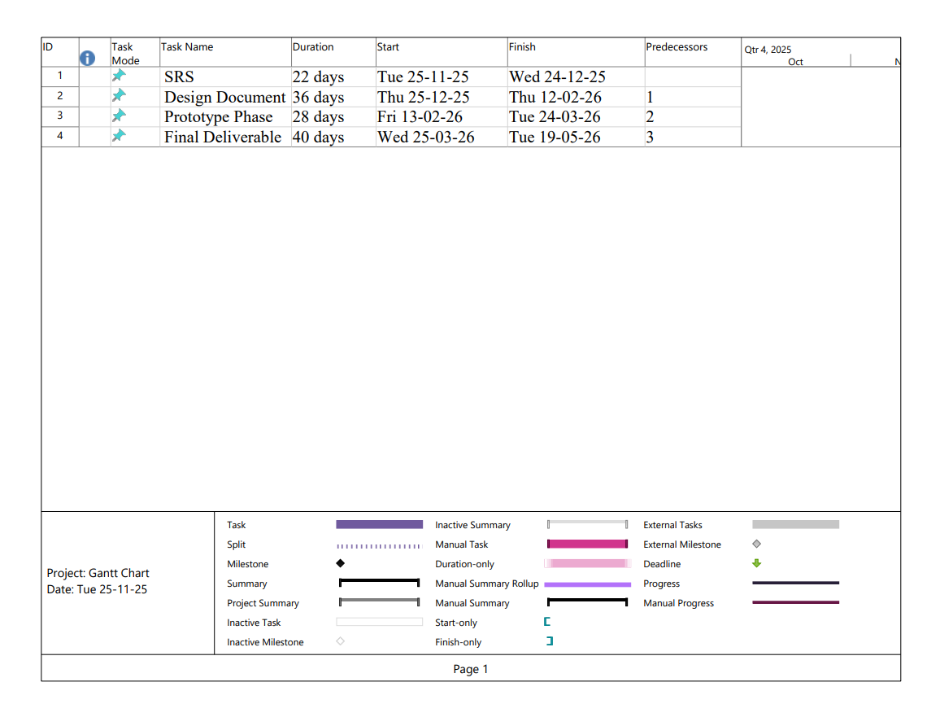

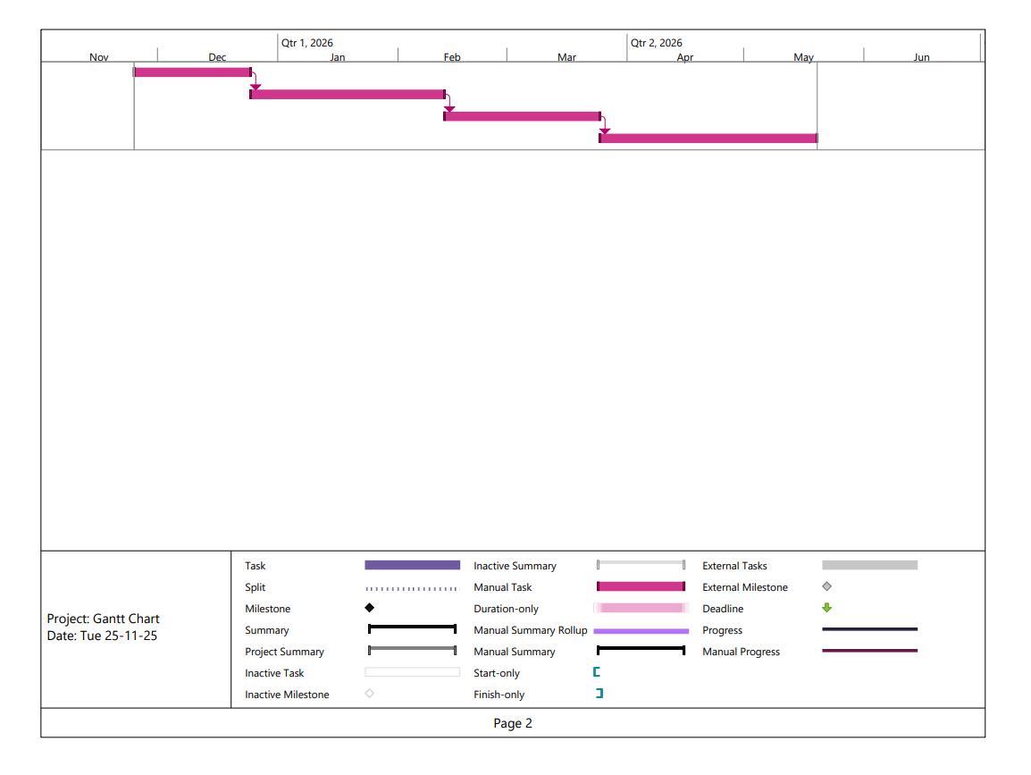

1.7.2 Project Schedule (Submission Calendar)

Following is the project submission calendar.

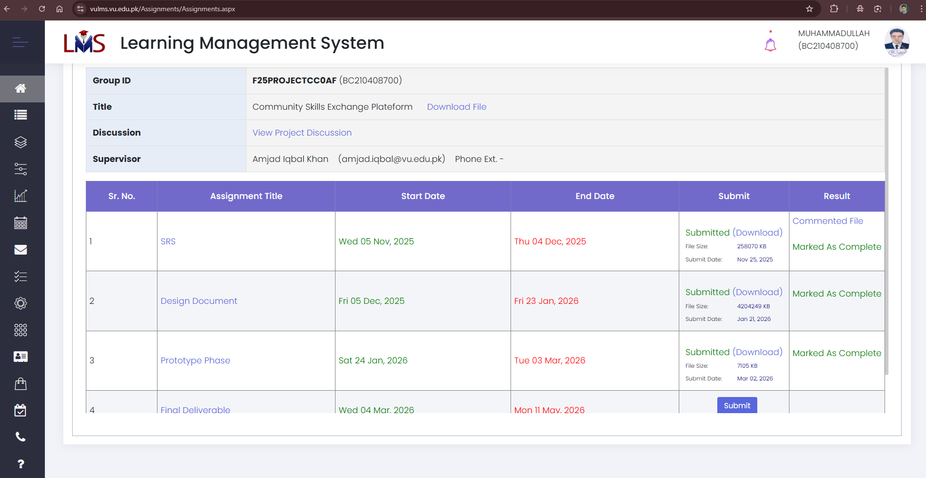

CHAPTER 2
Designing the Project

CHAPTER NO. 2
designing the project 12

2.1 Introduction

Design document represents detailed system design. The main purpose of design document is how the system will be structured and implemented during the software development phase. In short, design document turns requirements into a detailed blueprint which speed up software development process.
The design phase plays a crucial role in software development as it helps identify potential issues before implementation begins. By clearly defining system architecture and module responsibilities, this document improves communication among stakeholders, reduces development risks, and ensures consistency throughout the development process.
Key Benefits of Design Document Phase:
- Clarity and Alignment
Design document eliminates ambiguity by providing a clear vision.
- Early Problem Identification
By reading and understanding of design document before coding or implementation can identify potential problems at the early stage, which is easy to solve at this stage.

- Improved Estimation Accuracy
Detail design enables more precise effort estimation.
- Stakeholders Communication
Technical designs translated into accessible formats (diagrams, flowcharts) allow non-technical stakeholders to visualize the final product's structure and behavior.

2.2 purpose

The purpose of this design document is to provide a comprehensive blueprint of the SkillShare - Community Skills Exchange Platform, detailing the system architecture, component design, database schema, user interface layouts, and technical specifications required for successful implementation. This document serves as a bridge between the requirements analysis phase and the actual development phase, translating functional requirements into concrete technical specifications that guide developers throughout the coding process. It ensures that all stakeholders — including developers, project supervisors, and evaluators — have a clear and unified understanding of how the system will be structured, how different components will interact with each other, and what technologies will be employed to achieve the desired functionality. By documenting design decisions, data flow patterns, and module interactions, this document minimizes ambiguity, reduces development risks, and provides a reference point for future maintenance and enhancements of the platform.

2.3 scope

This design document provides a comprehensive technical blueprint for the SkillShare - Community Skills Exchange Platform, covering the complete system architecture, database schema, component design, and user interface specifications. The document details the frontend design using Next.js 15 and React 19 with TailwindCSS and shadcn/ui components, the backend architecture built on Strapi v5 CMS, the database structure with SQLite including entity relationships and data flow, the RESTful API endpoints for communication between frontend and backend, the authentication system using JWT with role-based access control, the email notification system using Nodemailer and Gmail SMTP, and the responsive user interface layouts for all pages including registration, dashboard, skill browsing, exchange management, reviews, and admin panel. This document serves as the primary reference for developers, guiding the implementation phase and ensuring consistency across all platform components while meeting the functional and non-functional requirements outlined in the Software Requirements Specification.

2.4 definitions, acronyms and abbreviations

Definitions:

Term | Definition
Component | A reusable, self-contained piece of UI in React that manages its own rendering and behavior
Context API | React's built-in state management solution for sharing data across components without prop drilling
Lifecycle Hook | Functions in Strapi that automatically execute when specific events occur (create, update, delete)
Content Type | A data structure in Strapi that defines the fields and relationships for a specific entity
Route | A URL path that maps to a specific page or API endpoint
Middleware | Software that sits between the request and response, processing or modifying data in transit
Provider | A service connector in Strapi that enables external integrations (email, upload, etc.)

Abbreviations & Acronyms:

Term | Full Form
Lib | Library
Nav | Navigation
JWT | JSON Web Token
SSR | Server-Side Rendering
Auth | Authentication
Config | Configuration
Res | Response

2.5 Architectural Representation (Architecture Diagram)

Here is the Tiered Architecture of the system.

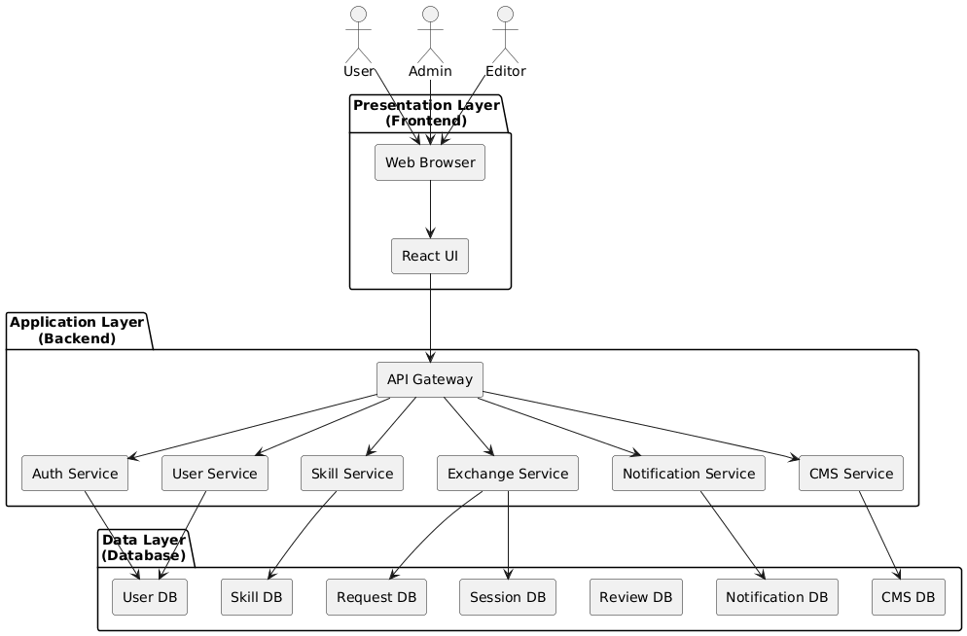

2.6 Dynamic Model: Sequence Diagrams

User Registration & Login:

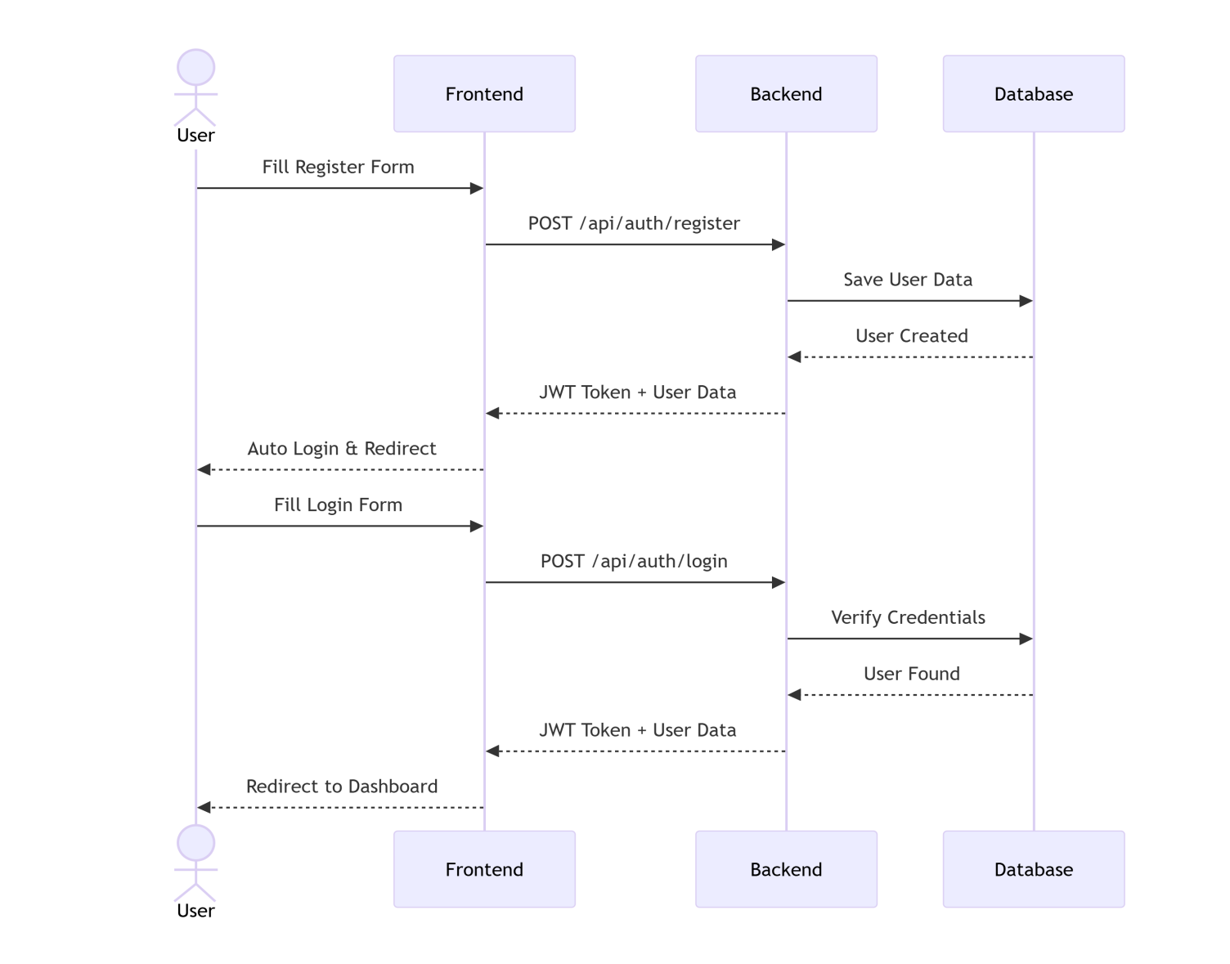

Skill Exchange Request:

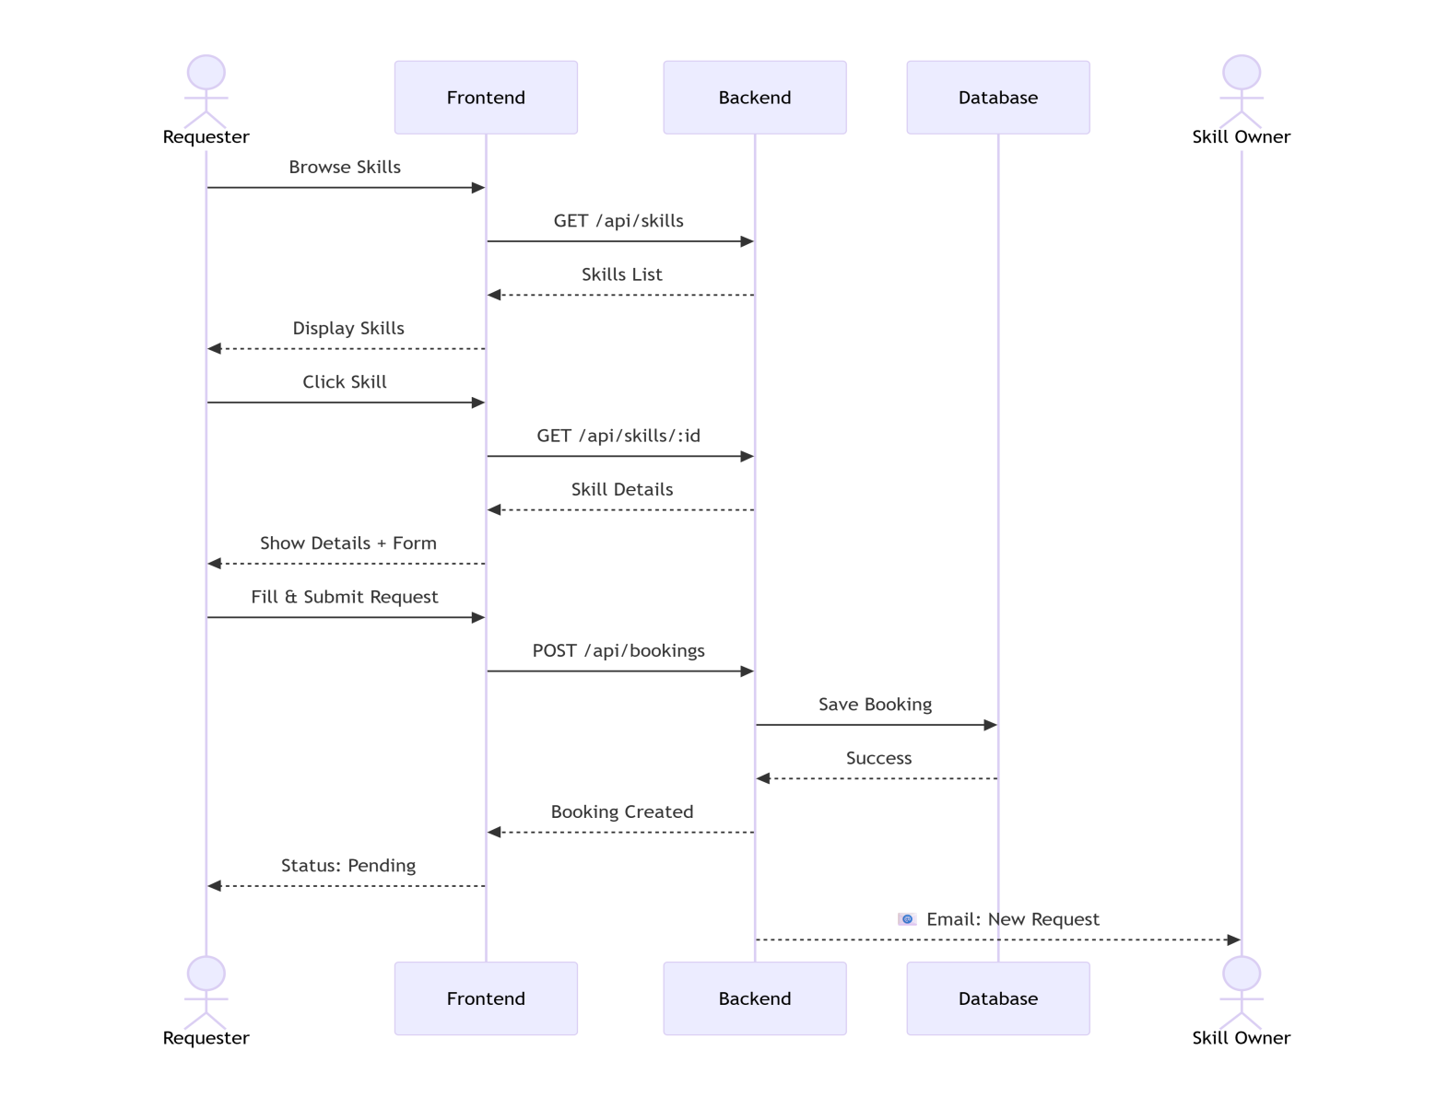

Accept and Complete Exchange:

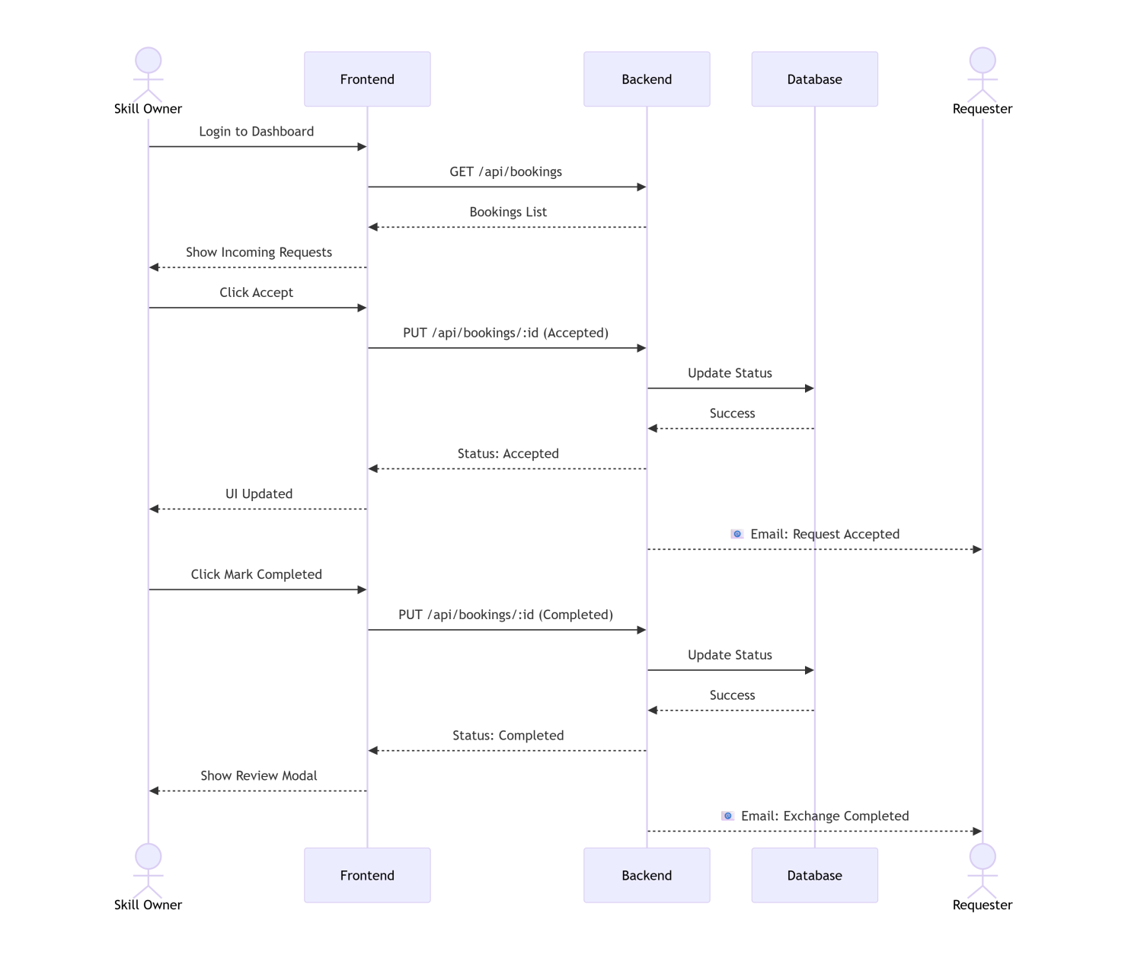

Rating & Review Submission:

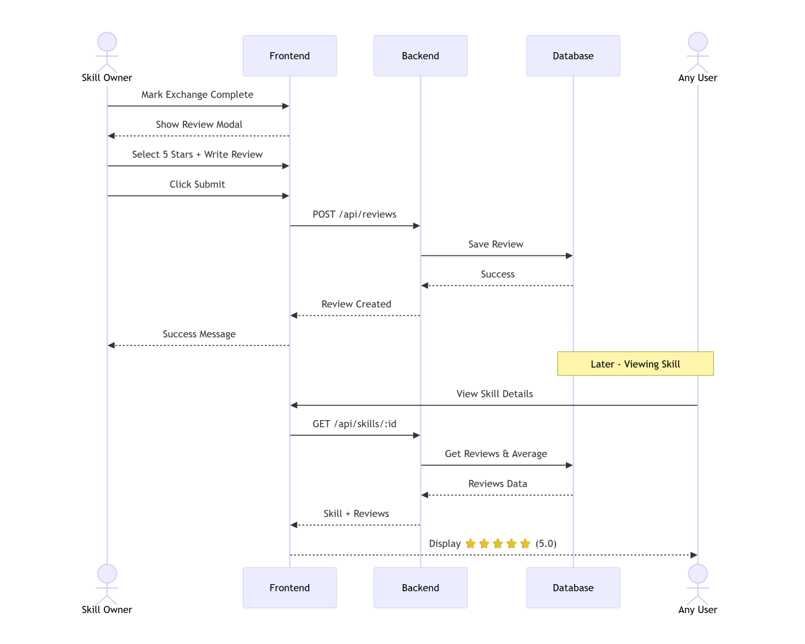

Admin User Management:

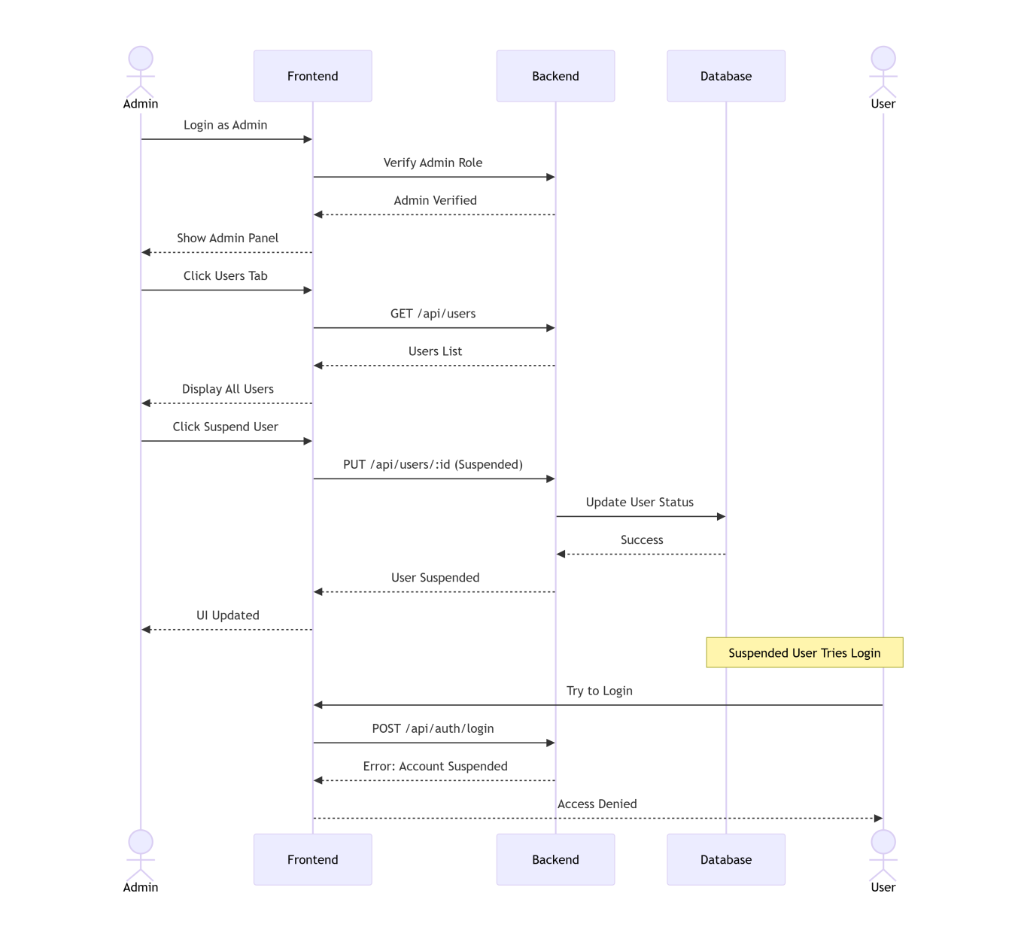

2.7 Object Model/Logical Model: Class Diagram

  - CORE USER & AUTHENTICATION CLASSES

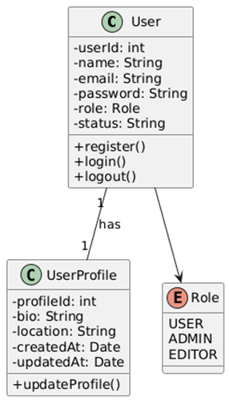

  - SKILLS & CATEGORIES

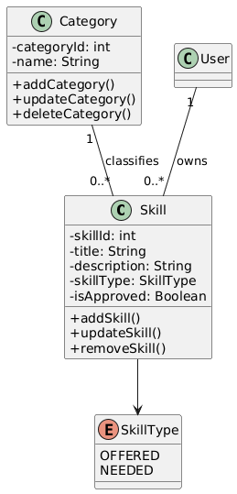

  - SKILL EXCHANGE REQUEST & SESSION BOOKING

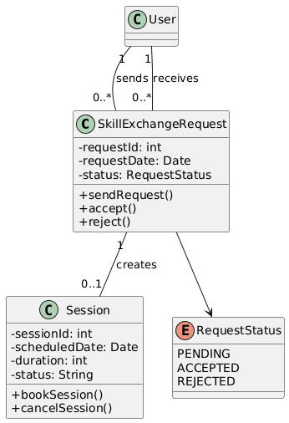

  - RATINGS, REVIEWS & NOTIFICATIONS

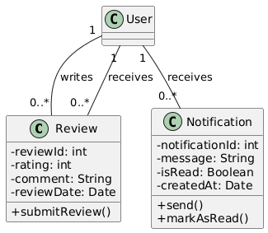

  - ADMIN, EDITOR, REPORTS & CMS

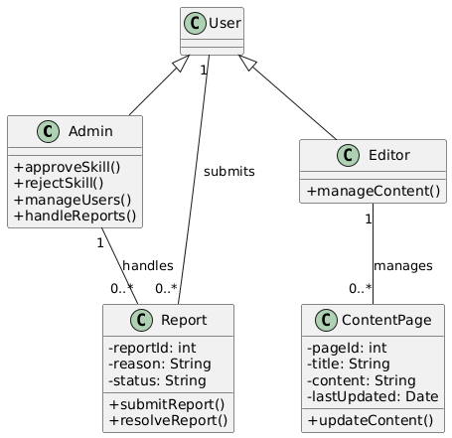

Complete Class/Logical Diagram

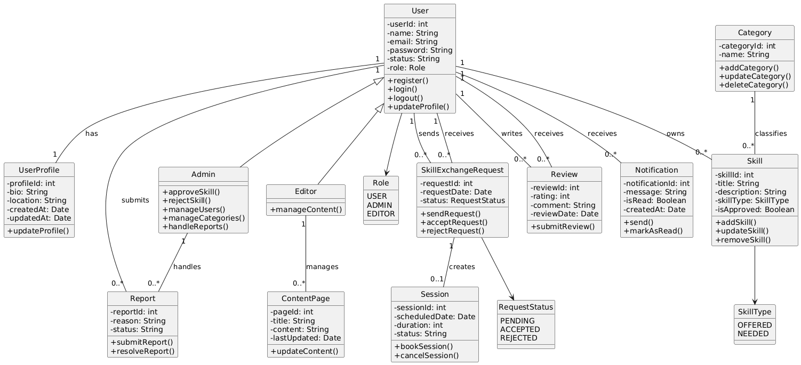

2.8 Database Model (Database Diagram)

Database Diagram

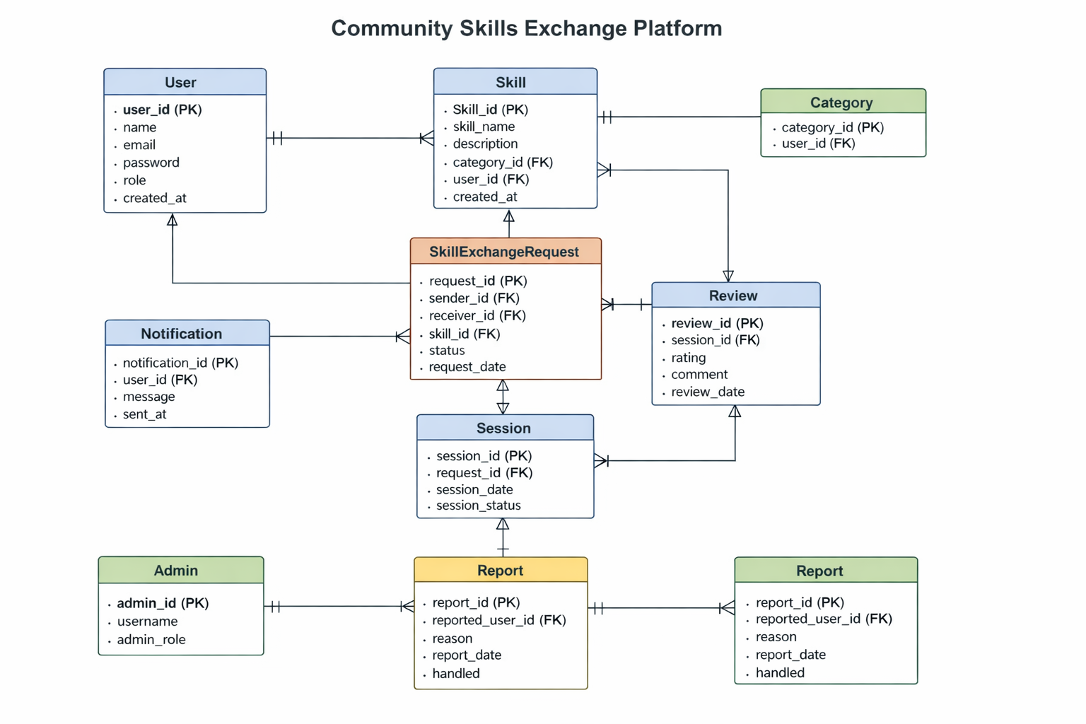

2.9 Graphical User Interfaces

  - Home
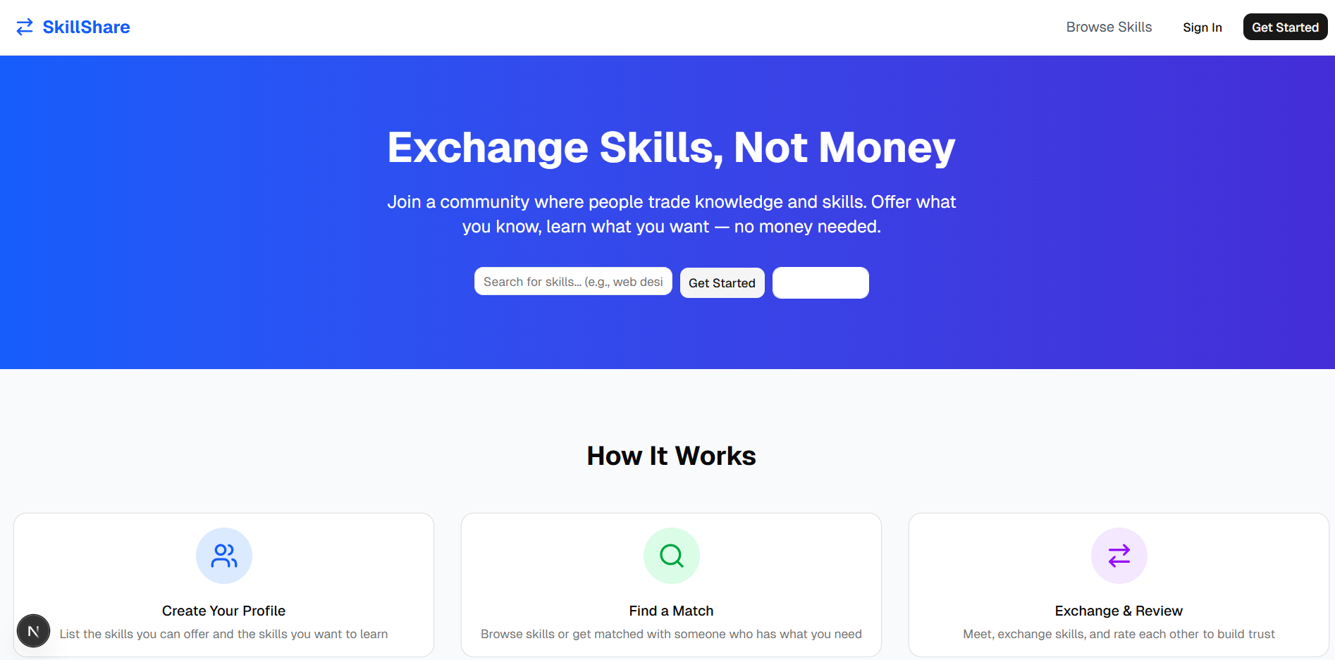

  - Popular Skills
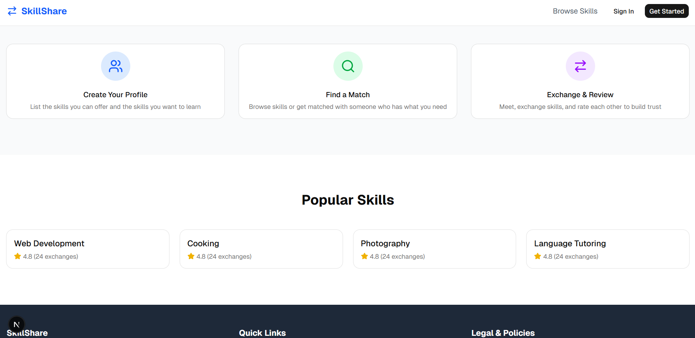

  - All Available Skills
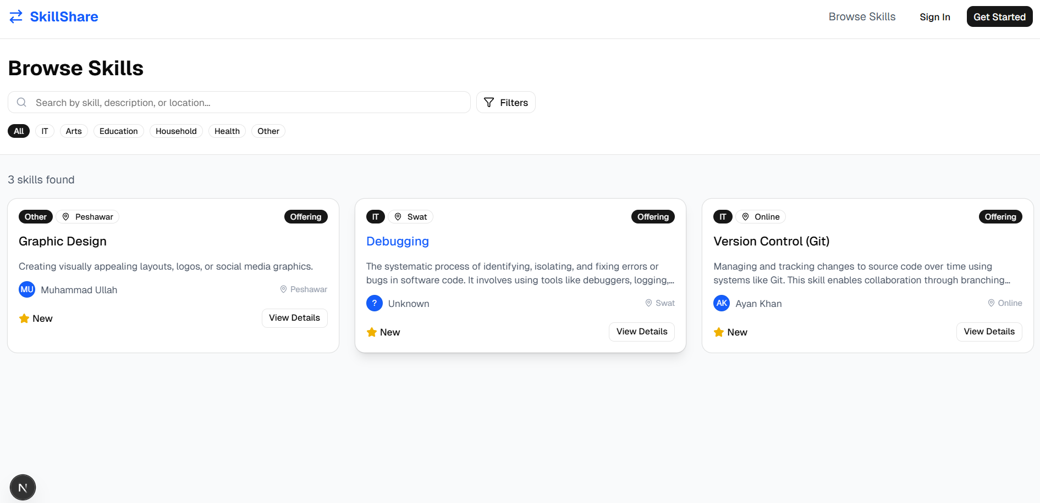

  - User Dashboard
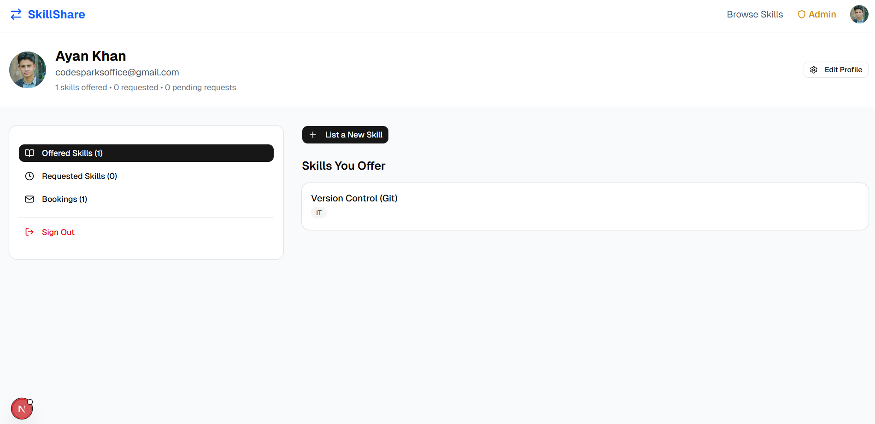

  - Admin Dashboard
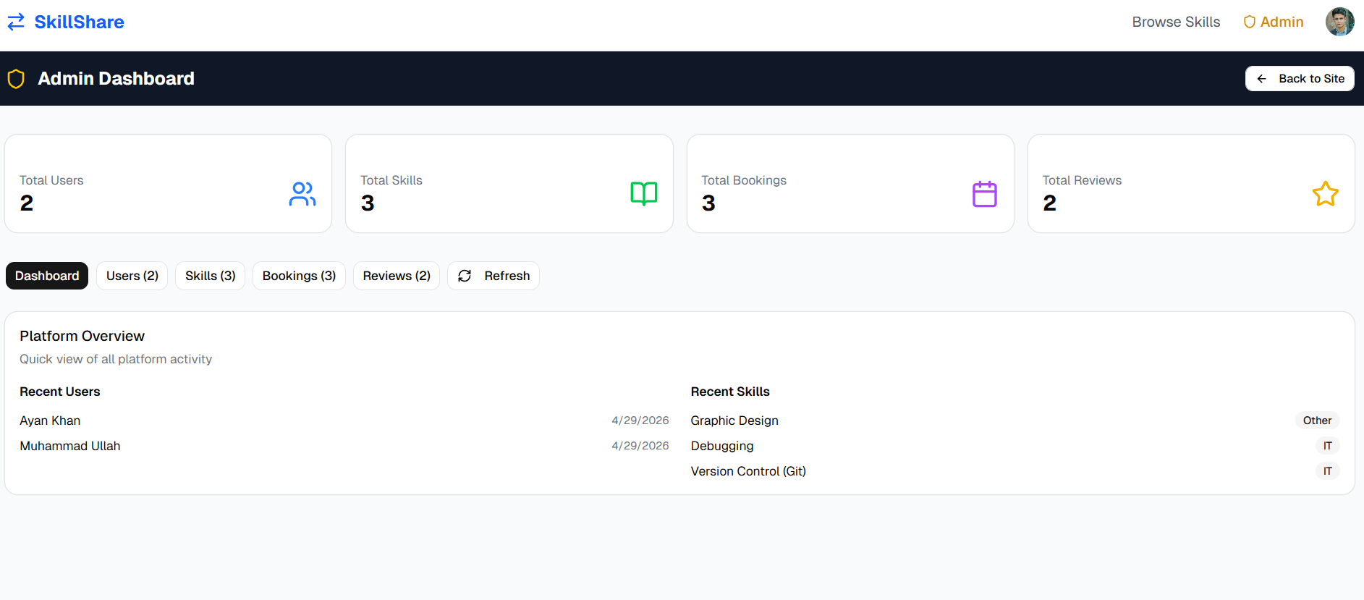

  - Admin Dashboard Active Users
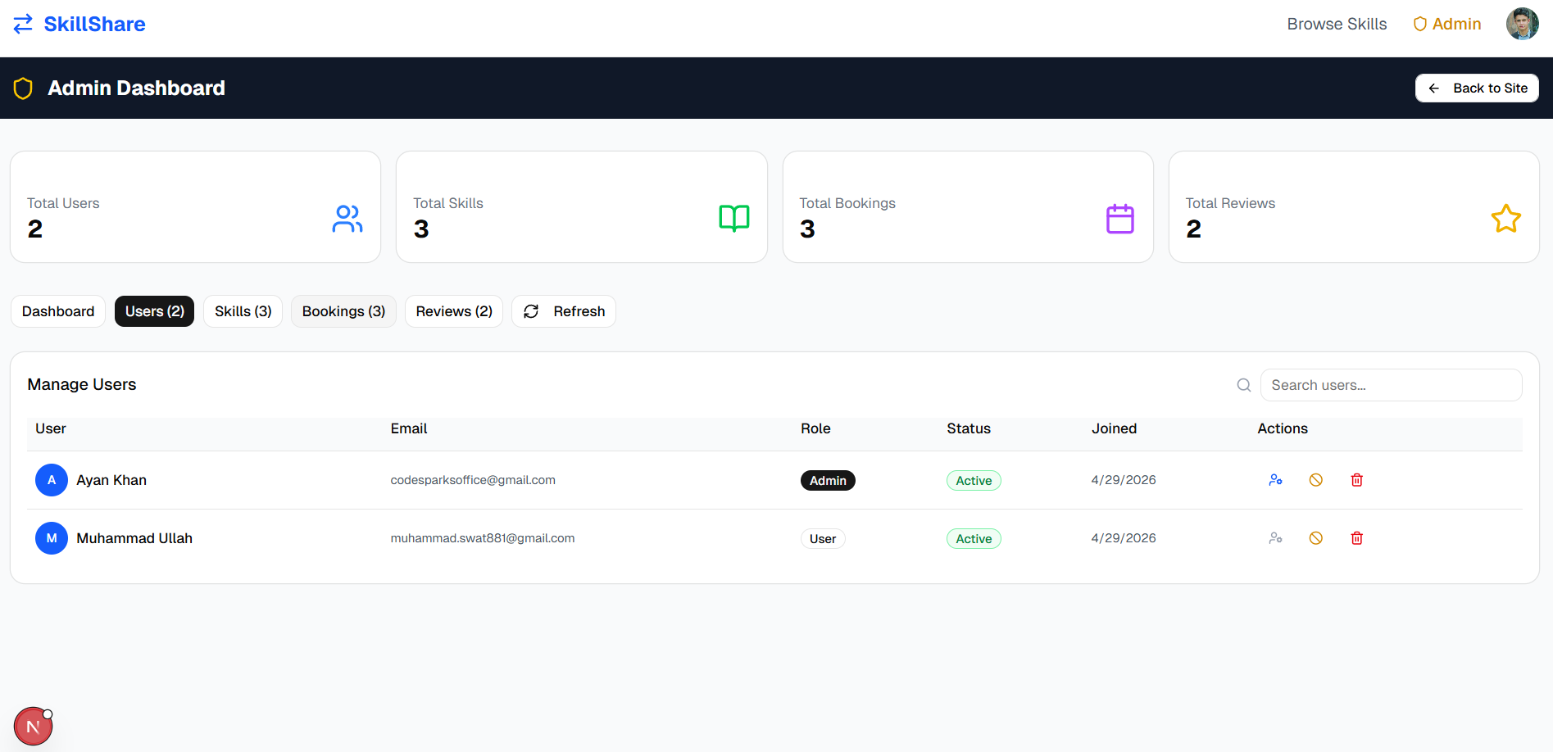

  - Edit Profile
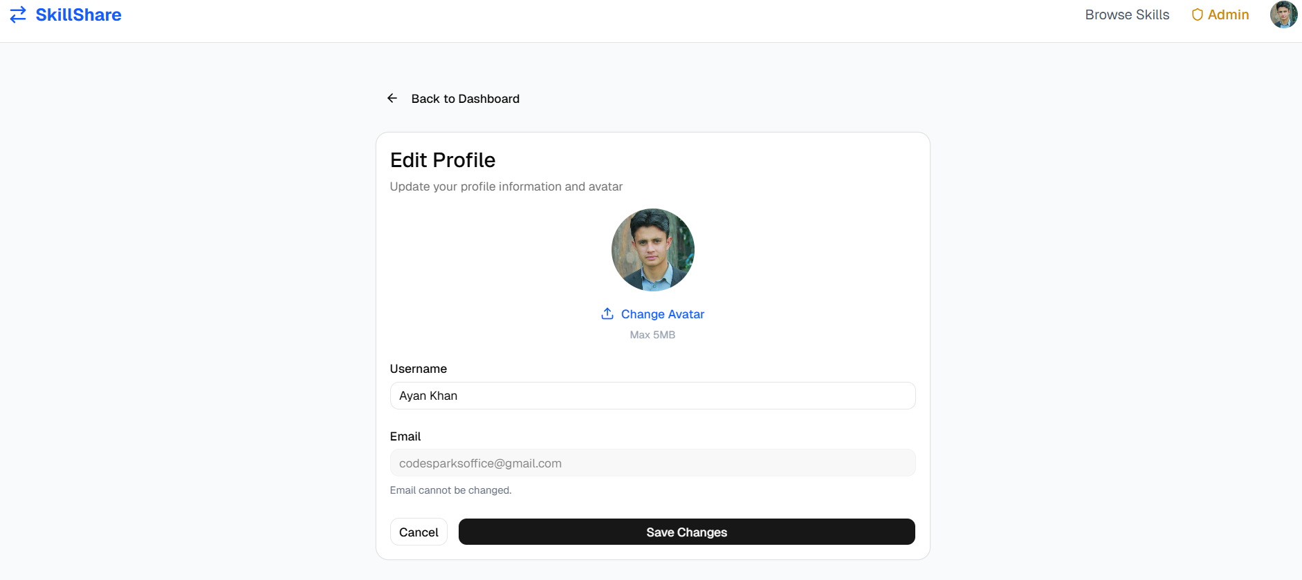

  - Add a New Skill
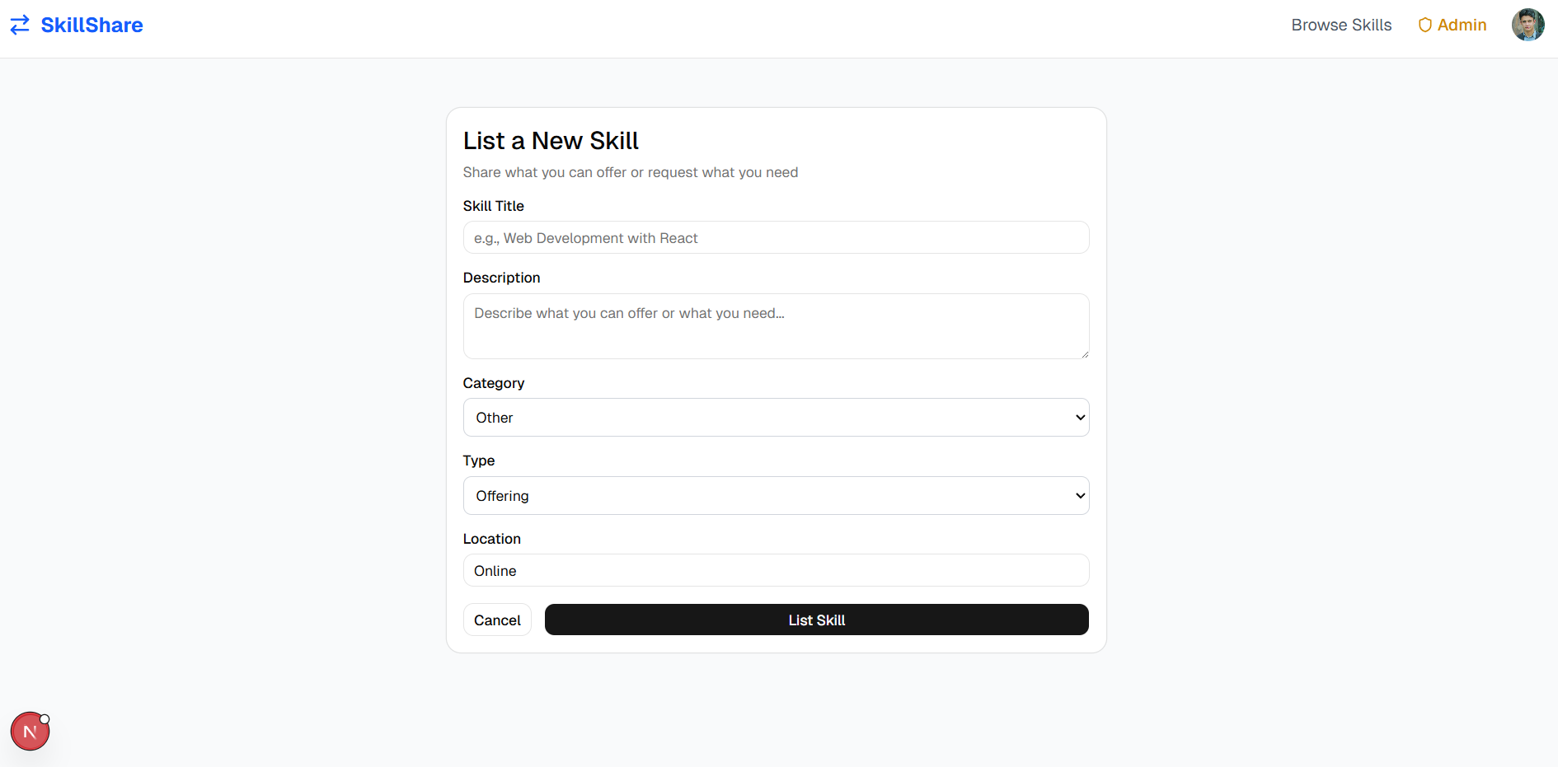

  - Frequently Asked Questions

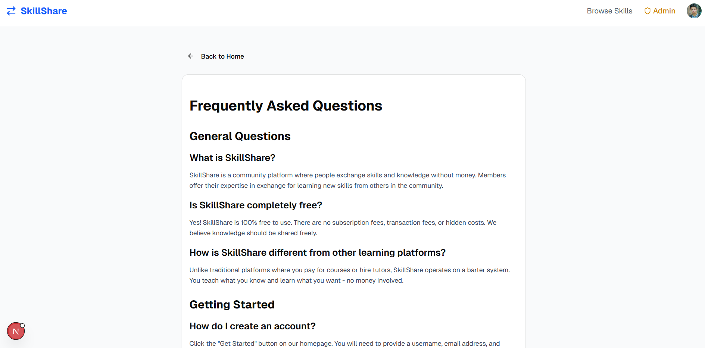

  - Skills Reviews

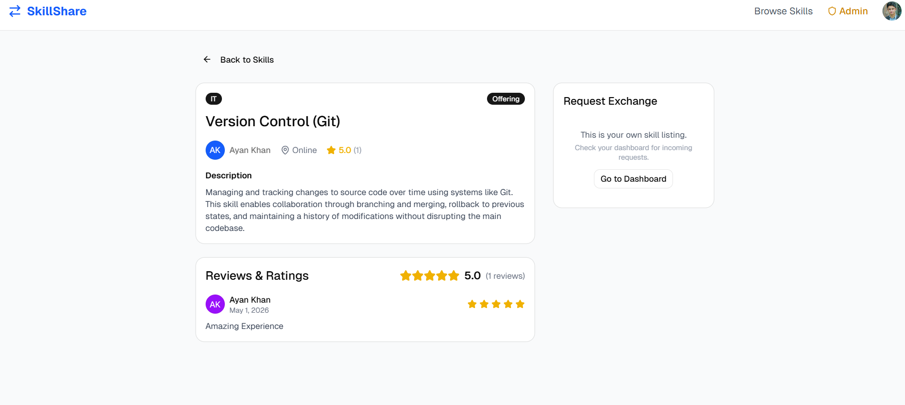

  - Accept/Decline Skill Request

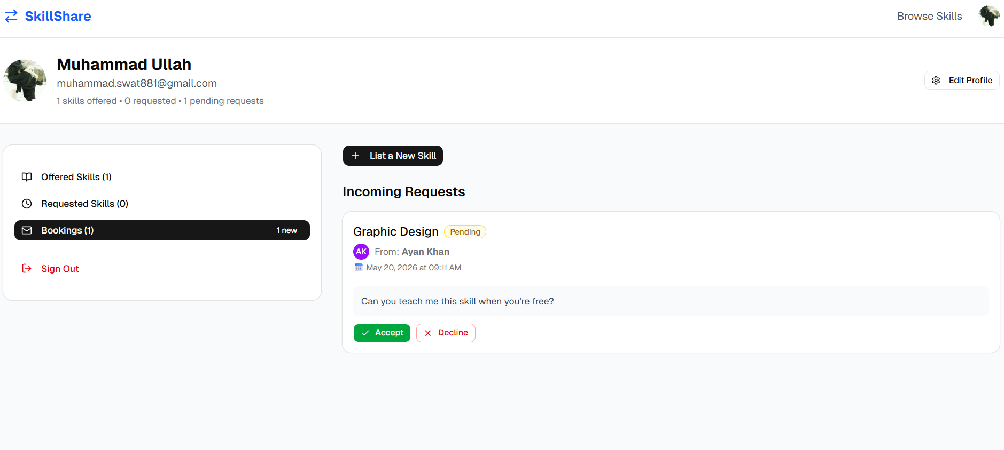

CHAPTER 3
Development

Chapter no.3
DEvelopment 13
3.1 Development plan (Architecture Diagram)

Here is the Tiered Architecture of the system

More in Depth:

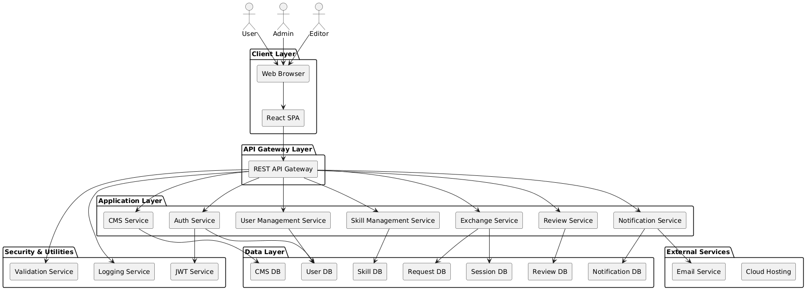
REFERENCES

Following are the references.

  - Next.js Documentation
https://nextjs.org/docs

  - React Documentation
https://react.dev/reference/react

  - Strapi Documentation
https://docs.strapi.io

  - TailwindCSS Documentation
https://tailwindcss.com/docs

  - shadcn/ui Documentation
https://ui.shadcn.com/docs

  - MDN Web Docs
https://developer.mozilla.org/en-US/docs/Web/JavaScript/Guide

APPENDIX

Appendix A: System Installation Guide

Prerequisites

- Node.js v20.x or higher
- npm v10.x or higher
- Git
- Visual Studio Code (recommended)

Installation Steps

Step 1: Open project folder.
Step 2: Setup Backend:

cd backend
npm install
npm run develop

Backend runs at: http://localhost:1337/admin

Step 3: Setup Frontend

cd frontend
npm install
npm run dev

Frontend runs at: http://localhost:3000

Appendix B: Strapi Configuration

Content Types Created

User (built-in) - Extended with avatar, role, account_status
Skill - title, description, category, skill_type, location
Booking - message, scheduled_date, booking_status
Review - rating, comment

Appendix C: Database Schema

Tables

- users - User accounts and profiles
- skills - Skill listings
- bookings - Exchange requests
- reviews - Ratings and reviews

Appendix D: API Endpoints

Authentication
Method | Endpoint | Description
POST | /api/auth/local/register | User registration
POST | /api/auth/local | User login
Skills
Method | Endpoint | Description
GET | /api/skills | Get all skills
GET | /api/skills/:id | Get single skill
POST | /api/skills | Create skill
PUT | /api/skills/:id | Update skill
DELETE | /api/skills/:id | Delete skill

Bookings
Method | Endpoint | Description
GET | /api/bookings | Get all bookings
POST | /api/bookings | Create booking
PUT | /api/bookings/:id | Update booking status
Reviews
Method | Endpoint | Description
GET | /api/reviews | Get all reviews
POST | /api/reviews | Create review

Appendix E: Project Screenshots

Screenshots Included:

- Home Page - Landing page with search and featured skills
- Registration Page - User signup form
- Login Page - User signin form
- Browse Skills - Skills listing with filters
- Skill Detail - Skill view with exchange request
- User Dashboard - Profile and skill management
- Booking Management - Incoming requests view
- Review Modal - Star rating and feedback
- Admin Dashboard - Platform statistics
- Admin User Management - User list with actions
- Profile Edit - Avatar upload and profile update
- About Page - Content page example
- FAQ Page - Frequently asked questions
- Terms & Conditions - Legal page
- Privacy Policy - Privacy information

(Screenshots are attached separately in the project graphical user interface section)

Appendix F: User Manual

For Regular Users

Getting Started

- Visit the platform URL
- Click "Get Started" to register
- Fill in username, email, and password
- Login with your credentials
Listing a Skill
- Go to Dashboard
- Click "List a New Skill"
- Fill in title, description, category
- Select "Offering" or "Requesting"
- Click "List Skill"
Requesting an Exchange
- Browse skills on the platform
- Click on a skill to view details
- Fill in preferred date and message
- Click "Send Request"
Managing Requests
- Go to Dashboard → Bookings
- View incoming requests
- Click "Accept" or "Decline"
- After exchange, click "Mark as Completed"
Rating an Exchange
- After marking complete, review modal appears
- Select star rating (1-5)
- Write optional review comment
- Click "Submit Review"

For Administrators

Accessing Admin Panel
- Login with admin credentials
- Click "Admin" in navigation bar
Managing Users
- Go to Users tab
- View all registered users
- Click ⛔ to suspend user
- Click ✅ to activate user
- Click 🗑️ to delete user
Managing Content
- Go to Skills/Bookings/Reviews tabs
- View all platform content
- Delete inappropriate content

Appendix G: Test Cases

Sample Test Cases

Test ID | Feature | Test Scenario | Expected Result | Status
TC-01 | Registration | Register with valid data | Account created, redirected to dashboard | ✅ Pass
TC-02 | Registration | Register with existing email | Error: Email already exists | ✅ Pass
TC-03 | Login | Login with valid credentials | Login successful, redirected to dashboard | ✅ Pass
TC-04 | Login | Login with wrong password | Error: Invalid credentials | ✅ Pass
TC-05 | Skill | Create skill with valid data | Skill listed on platform | ✅ Pass
TC-06 | Exchange | Request skill exchange | Request sent, status: Pending | ✅ Pass
TC-07 | Exchange | Request own skill | Error: Cannot request own skill | ✅ Pass
TC-08 | Exchange | Accept request | Status: Accepted, email sent | ✅ Pass
TC-09 | Exchange | Complete exchange | Status: Completed, review modal shown | ✅ Pass
TC-10 | Review | Submit review with 5 stars | Review saved, displayed on skill page | ✅ Pass
TC-11 | Admin | Suspend user | User status: Suspended, cannot login | ✅ Pass
TC-12 | Admin | Activate user | User status: Active, can login | ✅ Pass
TC-13 | Profile | Upload avatar | Avatar saved and displayed | ✅ Pass
TC-14 | Search | Search by keyword | Matching skills displayed | ✅ Pass
TC-15 | Filter | Filter by category | Only selected category shown | ✅ Pass

Appendix H: References

- Next.js Documentation - https://nextjs.org/docs
- React Documentation - https://react.dev/
- Strapi Documentation - https://docs.strapi.io/
- TailwindCSS Documentation - https://tailwindcss.com/docs
- shadcn/ui Documentation - https://ui.shadcn.com/
- Nodemailer Documentation - https://nodemailer.com/
- JWT Introduction - https://jwt.io/introduction
- SQLite Documentation - https://www.sqlite.org/docs.html

The End

